Software Requirements Specification (SRS) for Encrypted Chat Software

*Baseline version 0.1*

*Issued on : August 10, 2015*

Issued by : Ruben

Issued for : AnotherBlabla Client

**Change History**

|  |  |  |  |
| --- | --- | --- | --- |
| **Version** | **Date** | **Author** | **Changes** |
| 1.0 | August 10, 2015 | Ruben | initial version |
|  |  |  |  |

**Document Approval**

The following Software Requirements Specification has been accepted and approved by the following :

|  |  |  |  |
| --- | --- | --- | --- |
| **Name** | **Title** | **Date** | **Signature** |
| Devi |  | 8/8/15 |  |
| Ruben |  | 8/8/15 |  |

Table of Contents

1. INTRODUCTION 6

1.1. Purpose 6

1.2. Scope 6

1.3. Definitions, Acronyms, and Abbreviations 6

1.4. References 7

1.5. Overview 7

2. GENERAL DESCRIPTION 8

2.1. Product Perspective 8

2.2. Product Functions 8

2.3. User Characteristics 8

2.4. General Constraints 8

2.5. Assumptions and Dependencies 8

3. SPECIFIC REQUIREMENTS 9

3.1. External Interface Requirements 9

3.2. Functional Requirements 9

3.3. Use Cases 9

3.4. Classes/Objects 10

3.5. Non-Functional Requirements 10

3.6. Design Constraints 10

3.7. Other Requirements 10

4. ANALYSIS MODELS 11

4.1. Sequence Diagrams 11

4.2. State-Transition Diagrams (STD) 11

5. CHANGE MANAGEMENT PROCESS 12

A. Appendices 13

A.1. Appendix 1 13

A.2.Appendix 2 13

**CHAPTER 1**

# INTRODUCTION

## Purpose

This document will describe all the requirements to able to run the software.

## Scope

* 1. Product Name :Secure ChatSoftware

Language Used : Java Runtime environment

Minimum OS : Windows XP and above , Linux OS

RAM : 2GB above

* 1. This software is able to communicate with one server and clients in different computer. All messages being send are encrypted to secure

Benefits of this software:

Protect Data completely

Achieve security on all devices

All messages are being secured.

Guarantee Data Integrity

Ensure Compliance

Objective: enable to communicate with your clients in securely.

Note: This software does not provide any hardware.

## Definitions, Acronyms, and Abbreviations

**Advanced Encryption Standard (***AES)* is based on a design principle known as a substitution-permutation network, combination of both substitution and permutation

**JRE** Java Runtime Environment

## References

Coding: http://pirate.shu.edu/~wachsmut/Teaching/CSAS2214/Virtual/Lectures/chat-client-server.html

Encrypting: http://stackoverflow.com/questions/15906041/java-aes-cfb8-nopadding-encryption-and-charset

Language used: Java Sun

## Overview

This document will be divided into several parts. All contents are written in the table content.

**CHAPTER 2**

# GENERAL DESCRIPTION

## Product Perspective

This software is very simple, user friendly.

## Product Functions

This software enables to communicate with one server and clients in different computer.

## User Characteristics

All users need to understand how to run Java language.

## General Constraints

Regulatory policies : This software should be copied and sell to other party.

Software limitations : Available only intranet network, No GUI available.

Parallel operation : Administrator can run as server and client.

## Assumptions and Dependencies

All computers are installed with JRE and connected to intranet.

**CHAPTER 3**

# SPECIFIC REQUIREMENTS

## External Interface Requirements

Hardware

A computer with network interface card (NIC) to communicate with other computer

Software

OS used : Mac OS or Windows with Java Runtime Environment installed.

Software Screen format : Command Prompt

Database : No database required

## Functional Requirements

*Clear*

## Use Cases

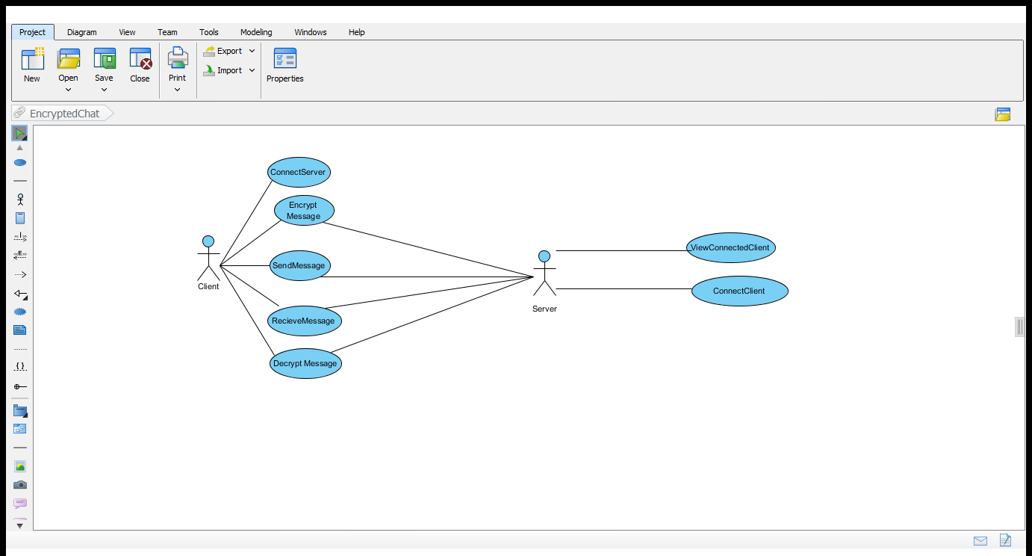

## Classes/Objects

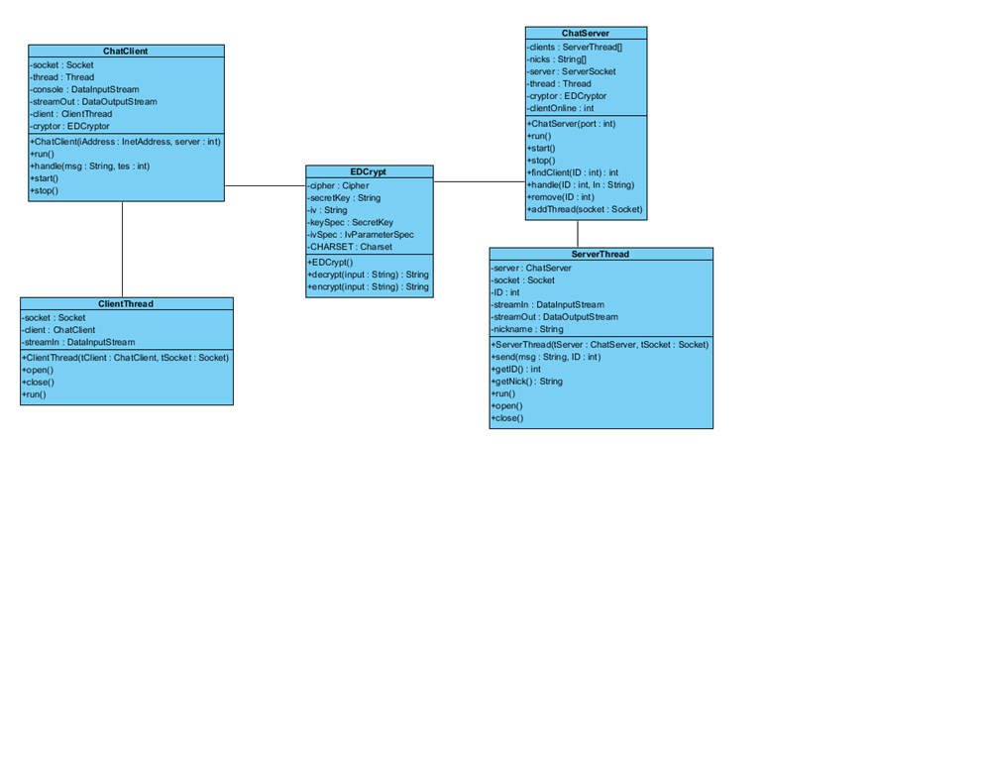

## Non-Functional Requirements

*Clear*

## Design Constraints

Program Size: 50 MB.

## Other Requirements

All computers are recommended to install with Antivirus Software, in order to prevent malicious software, malware and virus. Keep update JRE to run safely.

**CHAPTER 4**

# ANALYSIS MODELS

*List all analysis models used in developing specific requirements previously given in this SRS. Each model should include an introduction and a narrative description. Furthermore, each model should be traceable the SRS’s requirements.*

## Sequence Diagrams

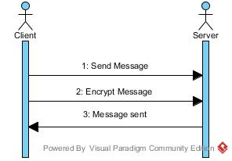

Send Message

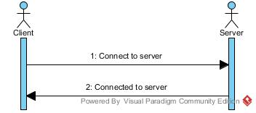

Connect to server

## State-Transition Diagrams (STD)



**CHAPTER 5**

# CHANGE MANAGEMENT PROCESS

*Identify and describe the process that will be used to update the SRS, as needed, when project scope or requirements change. Who can submit changes and by what means, and how these changes will be approved.*

Project manager and developers will keep updating the changes of this project. Any requirements will be considered and it will reliable, developers will develop and deliver to our clients.

# Appendices

*Appendices may be used to provide additional (and hopefully helpful) information. If present, the SRS should explicitly state whether the information contained within an appendix is to be considered as a part of the SRS’s overall set of requirements.*

## A.1. Appendix 1

## A.2.Appendix 2